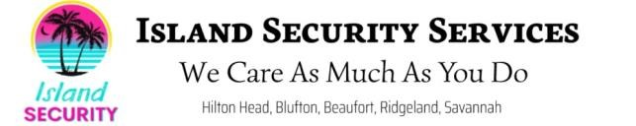 

Please fill out the entire application.

# EMPLOYER INFORMATION

Employer Name: Island Security Services

Address: 1 Greenwood Drive

City, State, and Zip Code: Hilton Head, South Carolina, 29926

Telephone: (843) 505-3536

Island Security Services is an Equal Opportunity Employer. We do not discriminate in our hiring practices on the basis of race, religion, color, sex, gender, identity, sexual orientation, age, disability, national origin, religion, veteran status, or any other status protected under federal, state, or local law.

All employment decisions at Island Security Services are decided on the basis of candidate qualifications, merit, and the unique needs of our business and the position.

# APPLICANT INFORMATION

Applicant Name: Click or tap here to enter text.

Address: Click or tap here to enter text.

City, State, and Zip Code: Click or tap here to enter text.

Telephone: Click or tap here to enter text. Alternate Phone: Click or tap here to enter text. Email Address: Click or tap here to enter text.

**EMPLOYMENT POSITION**

Employment Position Applied For:

Full or Part Time: Full time  Part time

When can you begin work if you are hired? Click or tap here to enter text.

Salary Desired: $Click or tap here to enter text. per Click or tap here to enter text.

Did anyone refer you to our company?

If yes, who: Click or tap here to enter text.